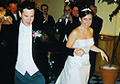
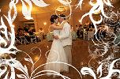
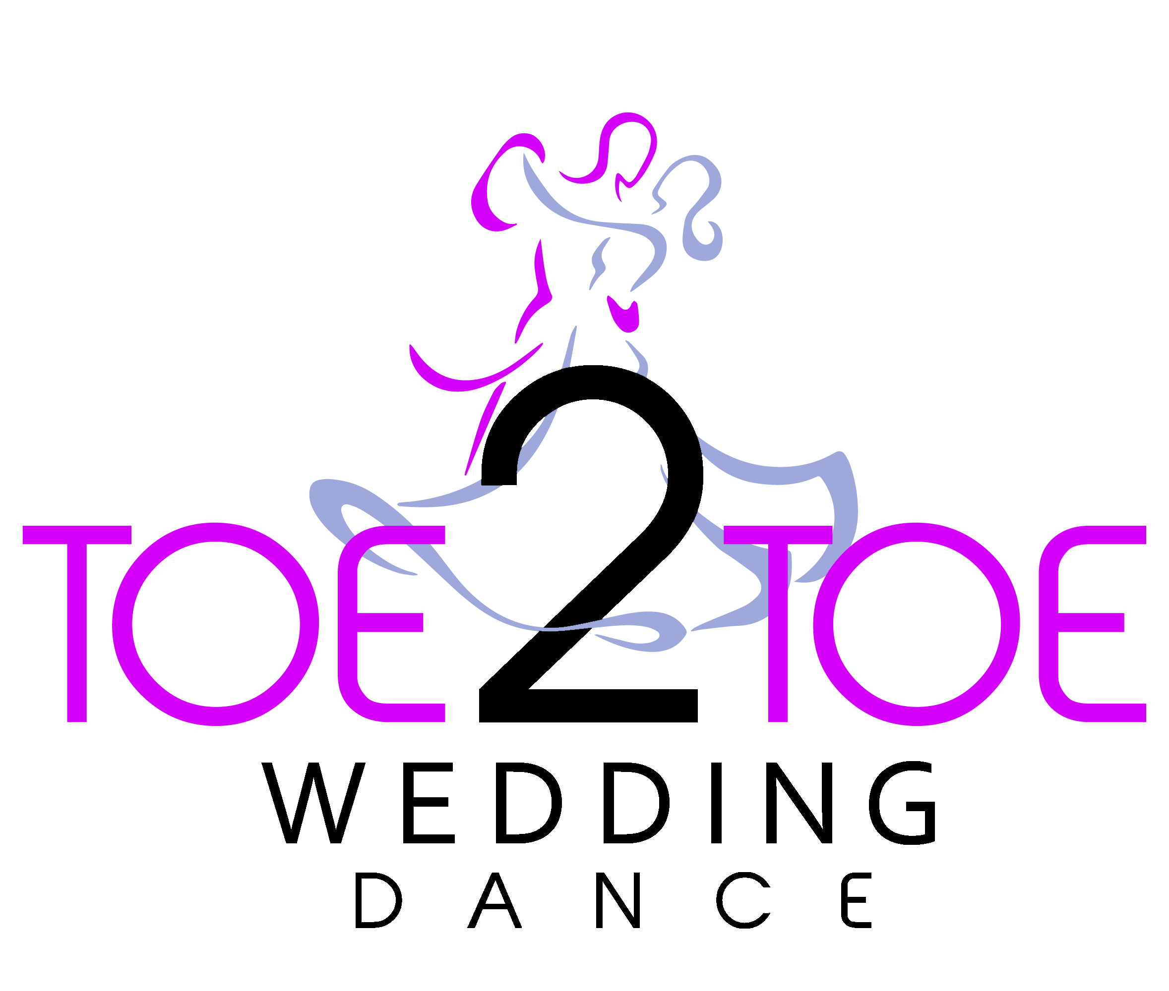

Toe 2 Toe Dance introduces its Wedding Dance Package for 2022/23
Toe 2 Toe Dance can make your first dance become a special moment between the happy couple and ensures your close family and friends revel in that special moment.
We start by offering all couples an Initial Consultation – the perfect chance to meet the teacher and talk through exactly what you need and all the options available.
Couples can then choose to book Individual Lessons or one of our packages, or even combine the two and come up with a lesson timetable that suit their timescale for that special first dance moment.

Our Initial consultation
We suggest both partners come along for the initial consultation if they can, but it’s not compulsory! And there’s no pressure to sign up for anything at that point simply discuss your needs if it fits then Toe 2 Toe Dance will guide you through
The informal meeting that lasts for approximately 30 minutes, it’s a good opportunity to meet us, and decide if this is really what you are looking for. All consultations are held at a time to suit both parties.
tHE PACKAGES
Bronze –This is the most popular choice for couples who have never danced before. It consists of three x 1hr lessons at the studio, plus a basic choreographed routine to a song of your choice.
Silver -This is for people who may have danced before, and want to show a little more of their skills on the dance floor. It consists of five x 1hr lessons at the studio, plus a full choreographed routine to a song of your choice. Music will be designed to fit the appropriate length of the dance and will be supplied on CD
GOLD - This is for people who may have danced before, and want to really go to town and show a full range of their skills on the dance floor. It consists of seven 1hr lessons at the studio, plus a choreographed routine to a song of your choice, and music adapted to the routine.

If our standard packages don’t suit, then just talk us through what you would like and we will tailor make a package for you.
If you are unsure whether to have the individual lessons or the package, then please feel free to discuss this at the consultation or contact us.
The style of choreography is chosen entirely by you. It can be a subtle, relaxed style of dancing – almost as if you haven’t had any lessons - or it can be a full-on show number designed to wow your guests!
Individual Lessons
Additionally we offer couples the chance for individual one-hour lessons.
These are perfect for couples who either have limited time before the wedding, i.e. the day or week before the big day! It’s also good for couples who can dance already and want to brush up on their moves or learn a few new ones!
One-off lessons are designed for couples that have a more relaxed approach on the day, as we will teach you a few moves and some turns, and then it’s down to you to go away and practice at home. There is no choreography, so every time you dance it will be different to the time before.
What does it cost?
iNITiAL CONSULTATION - £15.00 (30 mINS)
private lesson (NON-PACKAGE) - £60.00 (1 hOUR)
pACKAGE 1 - £175.00
pACKAGE 2 - £275.00
pACKAGE 3 - £350.00

Whatever your needs Toe 2 Toe Dance can provide just what you need to make your special moment even more special.
Give us a call now on 01463 513 613 or visit our website

