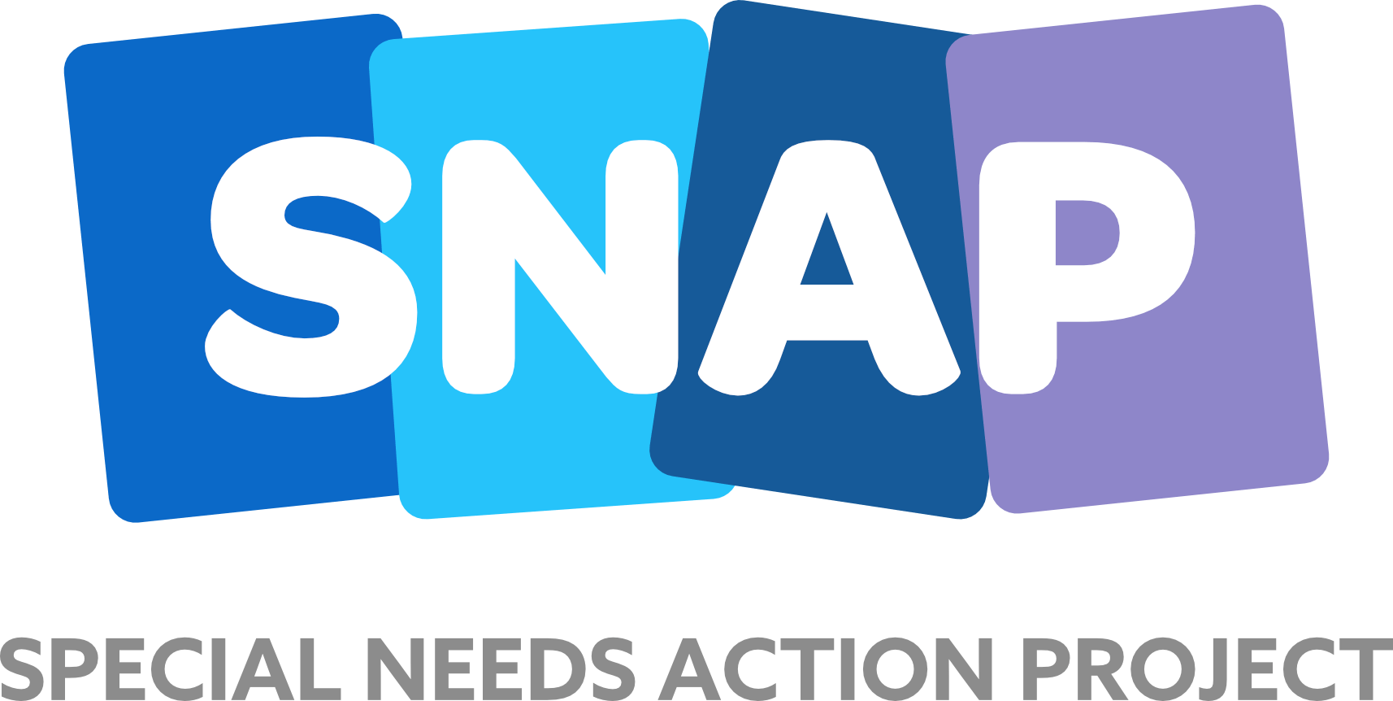

The Inverness “Glitter Ball” – 2026 !

Please complete the form and email it to glitterball@toe2toedance.org

Personal Details
Title: First Name: Surname:

Address:

Postcode
Contact Telephone Number, Home/Mobile:
Email Address:

Age: Occupation:

How would you like us to keep you informed about your application?
Please circle all that apply: - Phone Email Post

Additional Questions
Why do you want to take part in our event?

Do you have dance experience? Yes/No -
If yes please comment below: -

If successful you will be paired with a dancer. In order to pair you with the correct one can you please provide the following details: -
Height: Feet Inches
Build, please circle:
Small
Medium
Large

If successful you will be asked to fundraise at least £1,500 for SNAP. Can you tell us your ideas in achieving this and if you have fundraised in the past?

If successful you will require a corporate sponsor who is willing to donate £350 towards the costs of outfits, shoes etc. Can you advise if you have this in place or who you would approach?

Thank you for taking time to complete the application. A representative will be in contact after the closing date which is Sunday 1st January 2026

Privacy Statement
At SNAP & Toe 2 Toe Dance, we take your privacy seriously and we will only use the information you have provided on this form to process your application.

We will use the contact details you have provided to process your application and in order to provide a reply. We will not share your data and promise to keep your personal information safe and secure.

We will hold your personal data until the event is completed or until you withdraw your consent.

